**Project Report**

The assignment was to make a python script that fetches 500 latest App reviews for any app and do basic sentiment analysis on those reviews. The app of my choice was Clash of Clans. It is a strategy-based game that I’ve been playing since 2015 and enjoyed it. The python script scrapper.py, scrapes the latest reviews of the app from the google play store using the google_play_scraper library built-in python. It stores the data in the form of a CSV file.

The model preparation was done in the colab environment because of its support for rich in-built libraries. This model was built using the Roberta (Robustly Optimized BERT Pretraining Approach) which is present in the hugging face package. The results were very accurate when compared manually. A sample shot of the results is shown below:

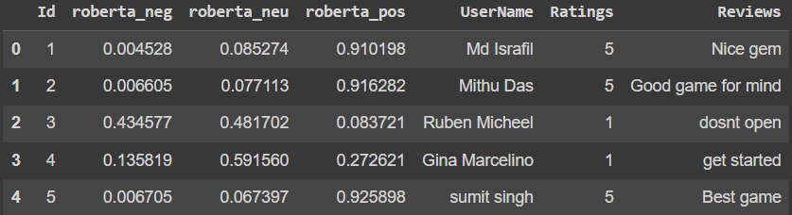

These results were also compared with the ratings provided by the user in the form of a bar plot.

